

TOPIC: WEEKLY WORK REPORT
NAME:ADVANCED WEB DESIGN
UNIT CODE: BIT3208
COURSE: BACHELOR OF SCIENCE IN INFORMATION TECHNOLOGY
DEPARTMENT: COMPUTING AND INFORMATICS

STUDENT DETAILS:
Student name : Mike Momanyi
Admission number:BSCCS/2024/57241
Course: BACHELOR OF SCIENCE IN INFORMATION TECHNOLOGY
Unit code:BIT3208
Unit Name:Advanced web design
Semester: 3.2
LECTURER : MICHAEL NYORO

Contents
Installation and Testing of Local Development Environment 2
WEEK 2 : Wireframes and GUI Design 4
Fig 1: Hand-drawn Wireframe 4
Fig 2: Dashboard Layout Design 5
5
Fig 3: Mobile View Mockup 5
6
Fig 4: Color Theme and Navigation Structure 6
Fig 5: GUI Prototype in Figma/Canva/Draw.io 6
7
8
WEEK 3 : JavaScript and PHP Basics 9
Frontend Interaction and Backend Foundations 9
Fig 1: JavaScript Form Validation 9
9
Fig 2: Password Strength Checker 9
10
Fig 3: PHP Syntax Practice 10
10
11
Fig 4: Database Connection Script 11
11
Fig 5: Dynamic User Input Handling 12
12
Week 4: 12
Server-Side Components and Backend Development Foundations 12
Task 1 – Understanding Server-Side Programming 12
Task 2 – HTML Forms and PHP Integration 15
Task 3 – Simple Authentication System 18
Task 4 – Backend Folder Organization 21
Week 5 22
Database Components and CRUD Operations 22

WEEK 1: Local environment setup

Installation and Testing of Local Development Environment

Github link:

https://github.com/Hami-bit/NexaBank/tree/main/Week1
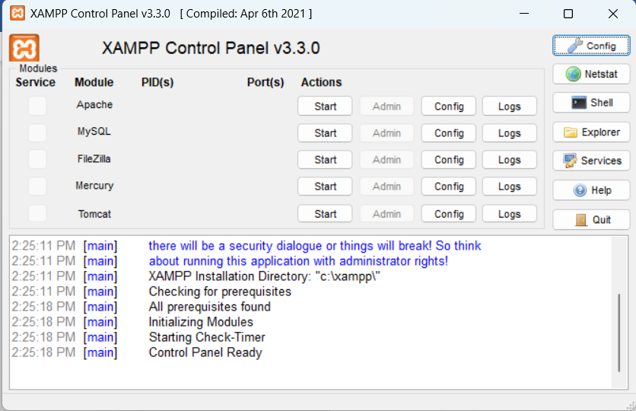

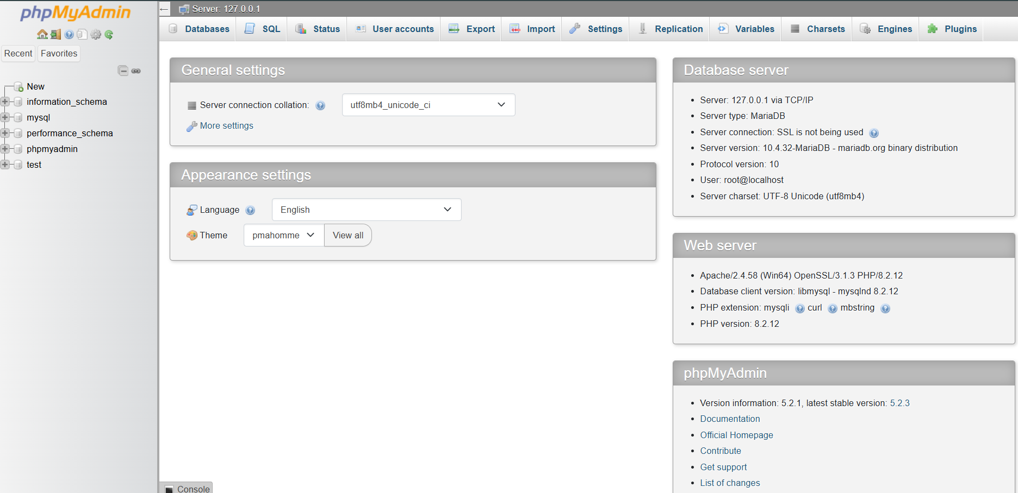
TESTING FOR HELLO WORLD IN PHP PAGE :
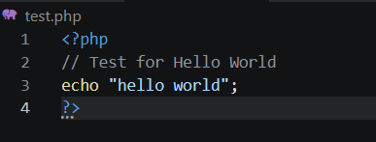
DATABASE CONNECTION TEST:
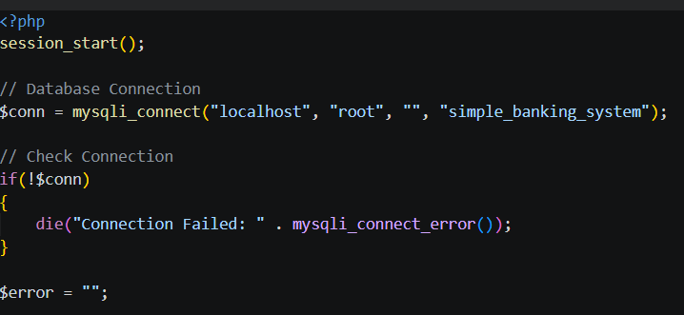
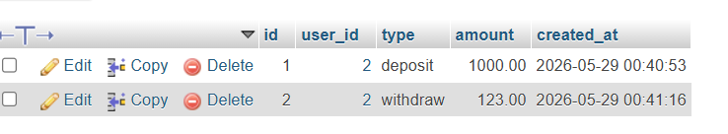

MY REFLECTION:
-During this setup, I learned how to configure a local web development environment using XAMPP, Apache, PHP, and MySQL. Fig 1 confirms successful installation of XAMPP, while Fig 2 demonstrates that Apache and MySQL services were running correctly. Fig 3 shows successful access of the localhost server through a web browser. Fig 4 verifies that the PHP environment was functioning properly using a Hello World test page. Fig 5 confirms successful database connectivity between PHP and MySQL using mysqli_connect().

WEEK 2 : Wireframes and GUI Design
User interface planning and system design

Fig 1: Hand-drawn Wireframe
(Login/Homepage)
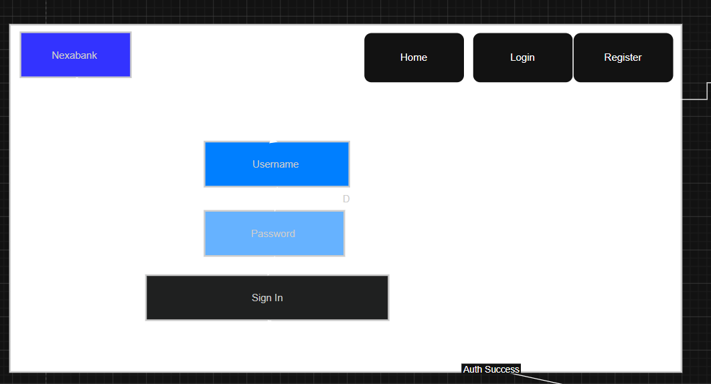

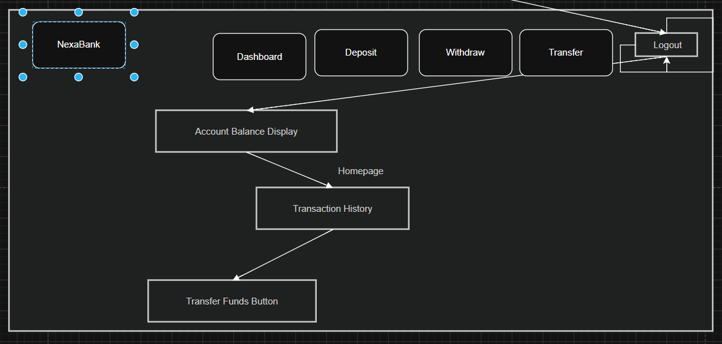

Fig 2: Dashboard Layout Design

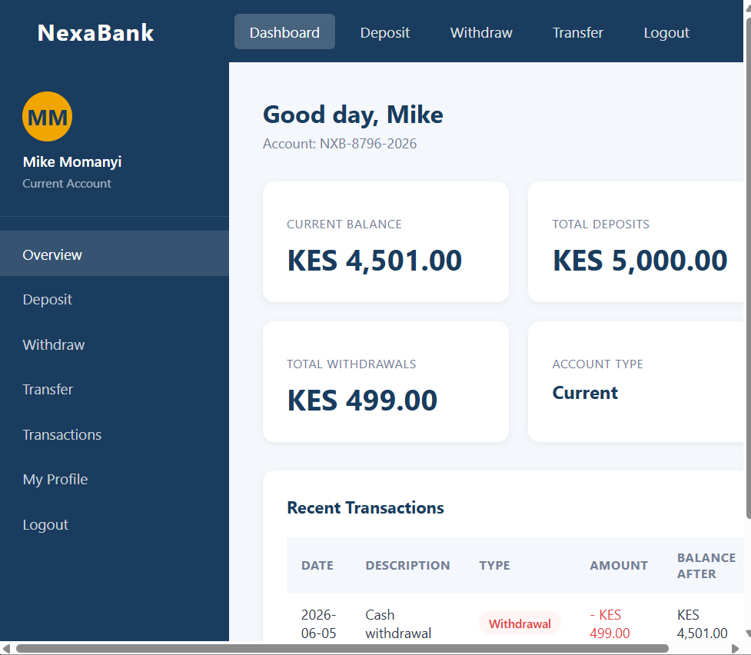

Fig 3: Mobile View Mockup

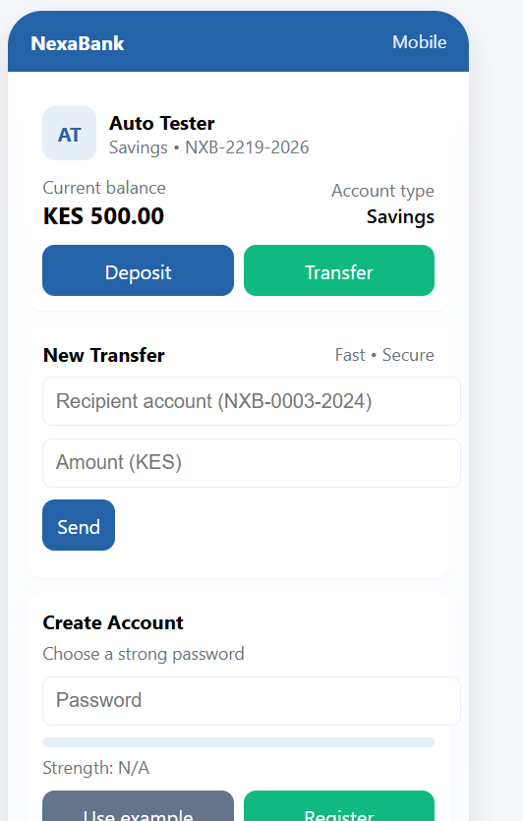

Fig 4: Color Theme and Navigation Structure

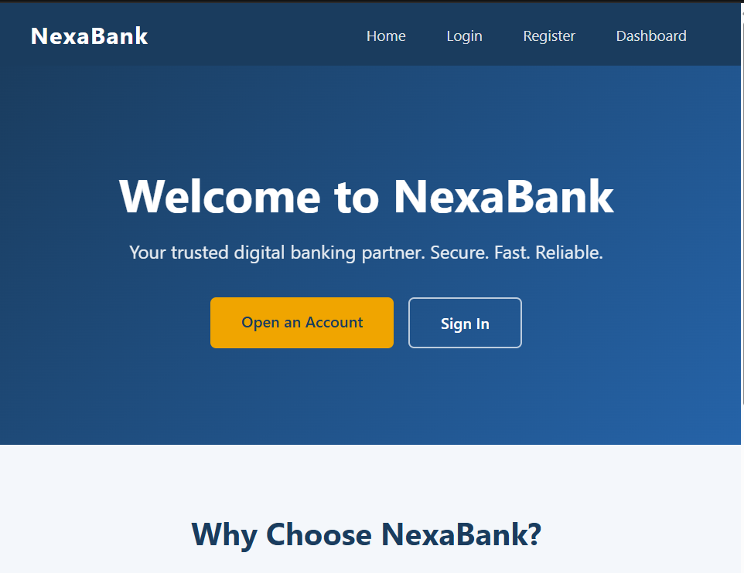

Fig 5: GUI Prototype in Figma/Canva/Draw.io

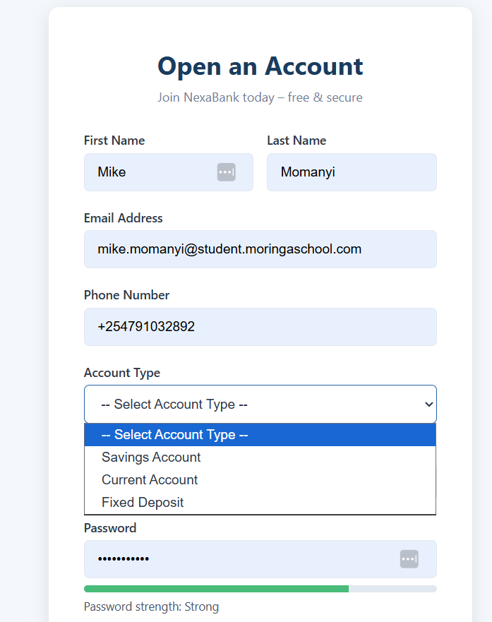

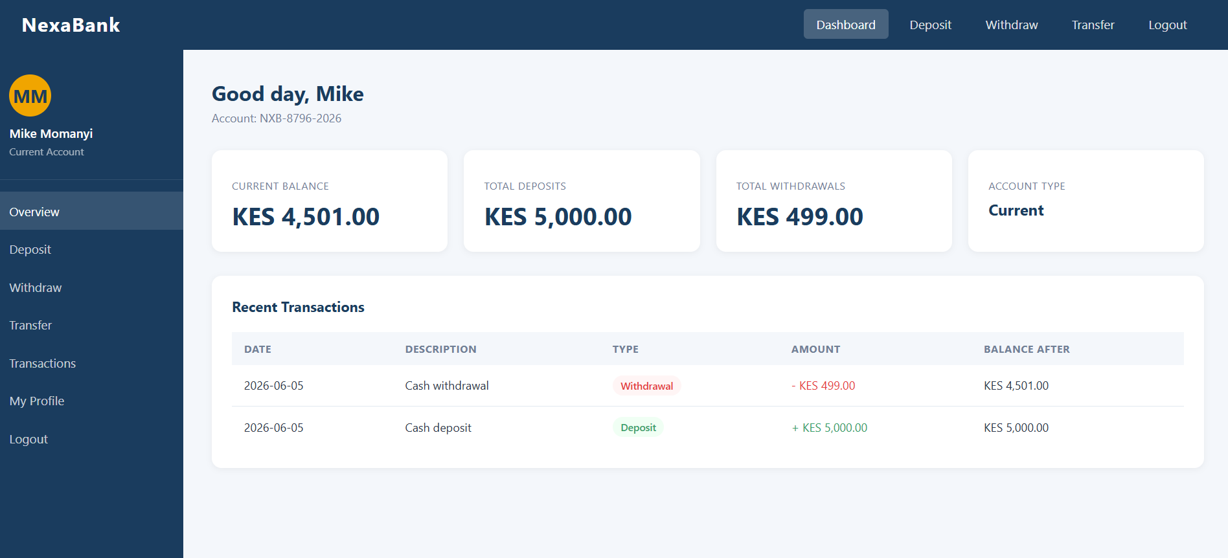

MY Reflection:
-The simple banking system design was selected to provide an easy and user-friendly interface for customers and administrators. The dashboard layout was organized clearly to help users access features such as account balance, deposits, withdrawals, and transaction history with minimal clicks. Mobile view mockups were included to ensure the system remains responsive on smartphones and tablets. The navigation structure was planned to improve movement between pages without confusion. The selected color theme improved readability and professionalism. The GUI prototype created in Figma helped visualize the final system before development and ensured the design met user requirements effectively.

WEEK 3 : JavaScript and PHP Basics

Frontend Interaction and Backend Foundations

Fig 1: JavaScript Form Validation

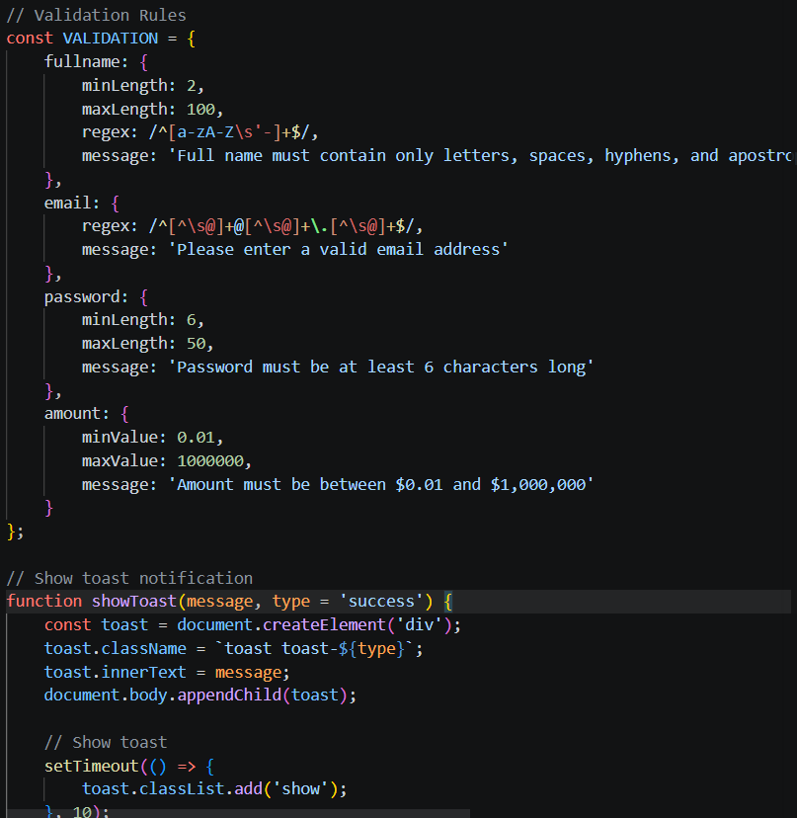

Fig 2: Password Strength Checker

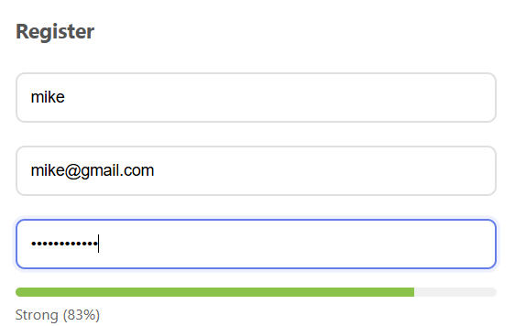

Fig 3: PHP Syntax Practice

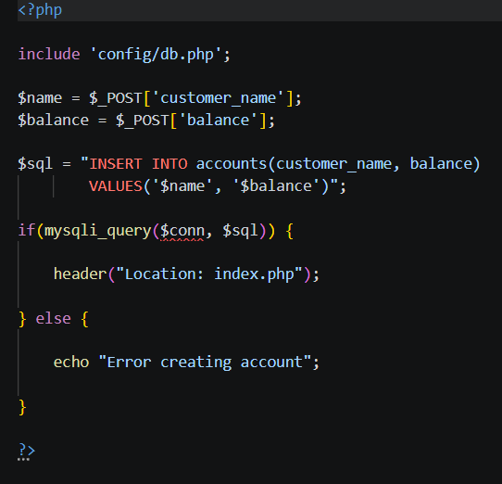

Fig 4: Database Connection Script

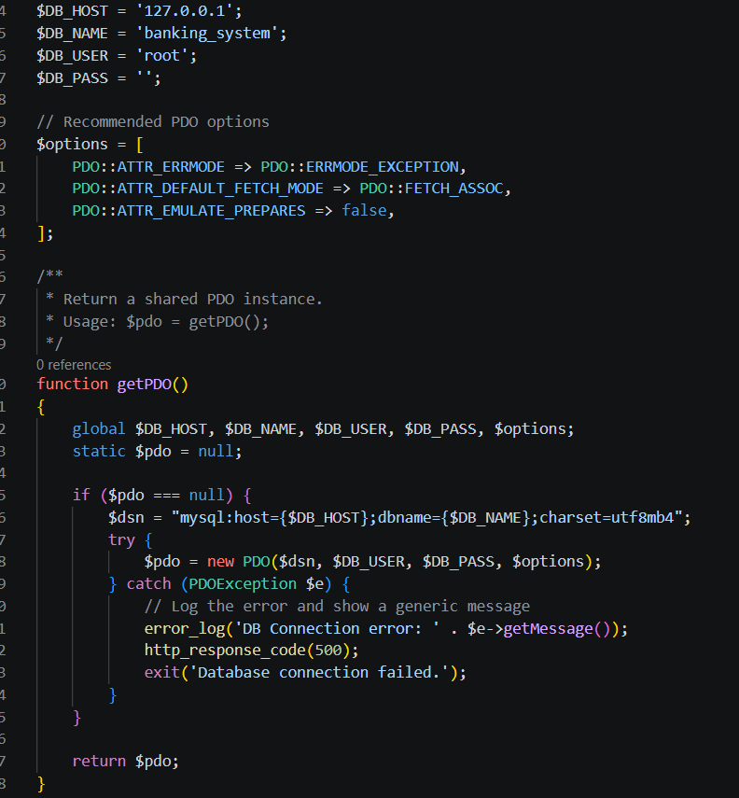

Fig 5: Dynamic User Input Handling

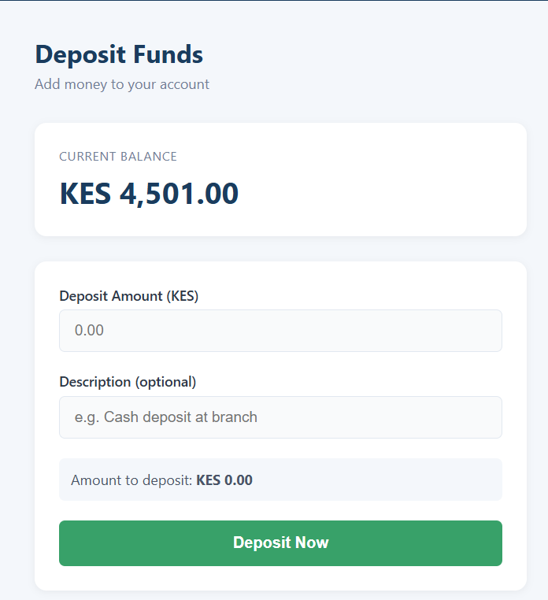

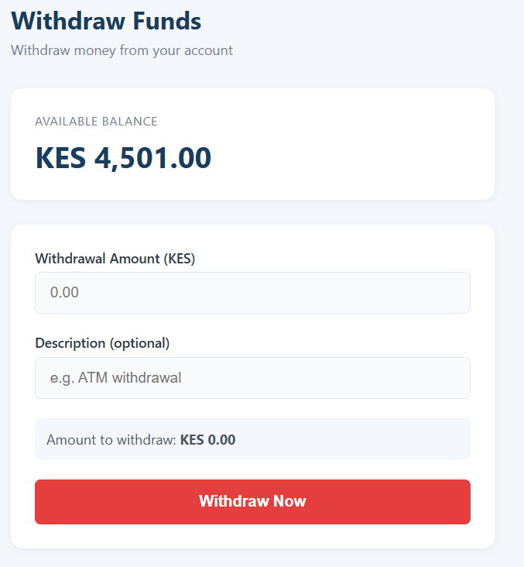

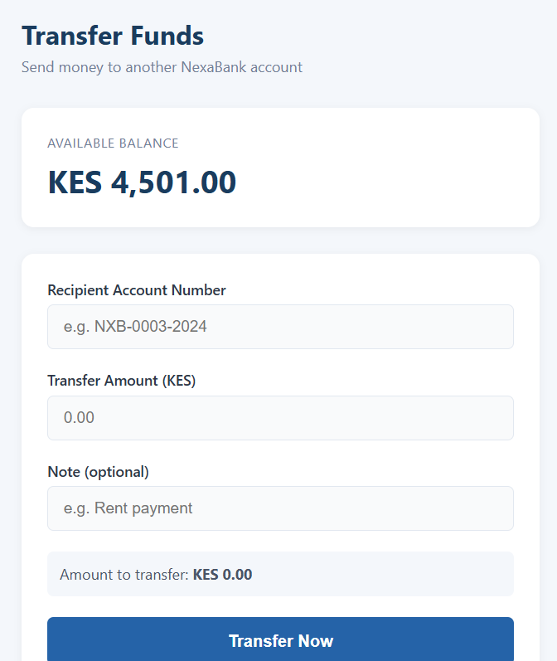

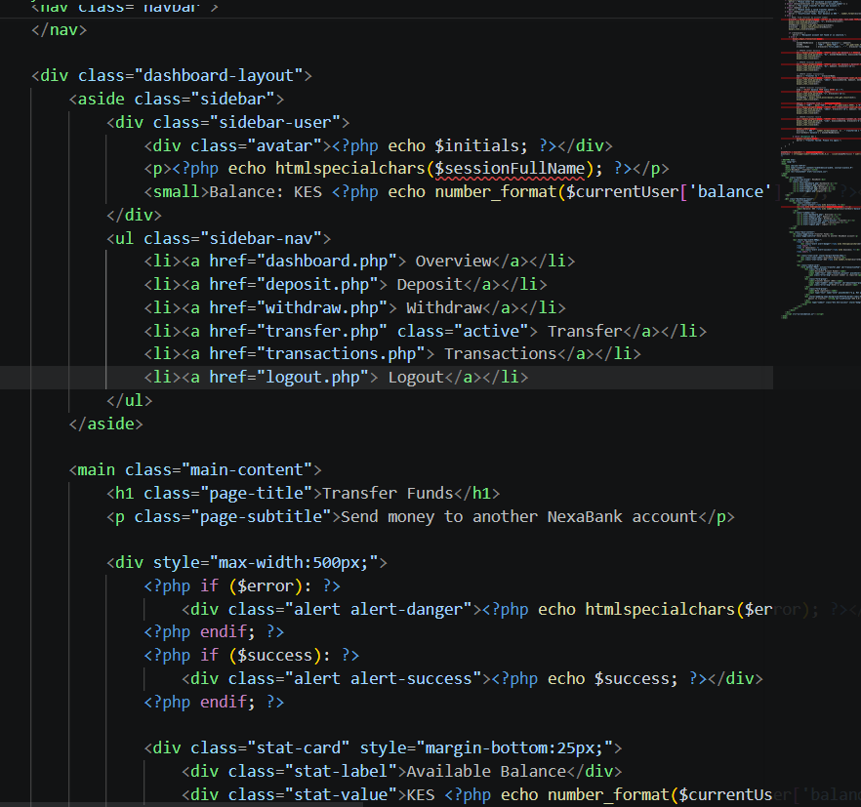

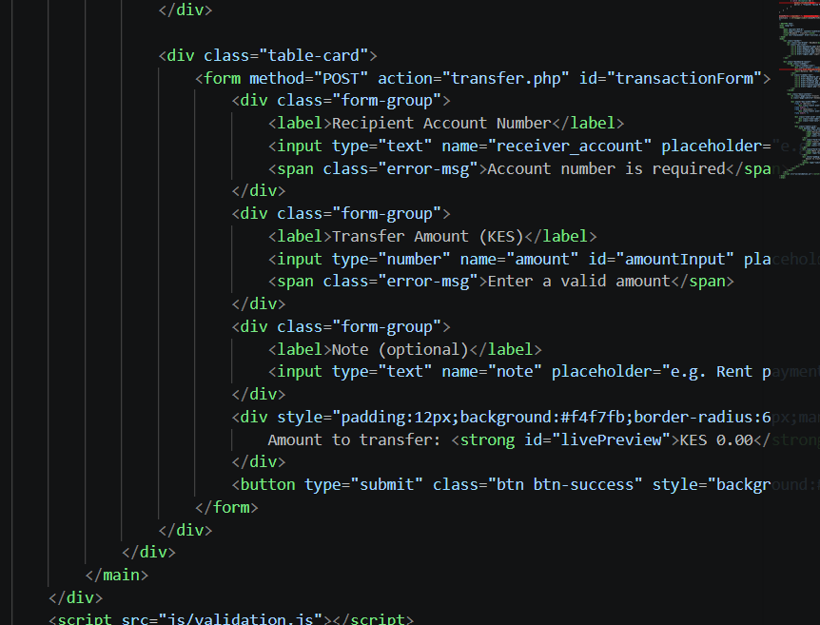
MY Reflection:
-The simple banking system demonstrated interaction between frontend and backend technologies using HTML, JavaScript, PHP, and MySQL. JavaScript validation was implemented to prevent empty or incorrect form submissions before data reached the server. The password strength checker improved account security by guiding users to create stronger passwords. PHP scripts processed user requests and handled communication with the database. The database connection script confirmed successful integration between PHP and MySQL for storing and retrieving user records. Dynamic user input handling allowed users to perform transactions and view account details efficiently. The screenshots show system development progress, backend integration, and successful user interaction flow also shows the code snippets.

Week 4:

Server-Side Components and Backend Development Foundations
-Introducing dynamic backend processing and real user interaction systems.

Task 1 – Understanding Server-Side Programming
- Simple PHP processing page

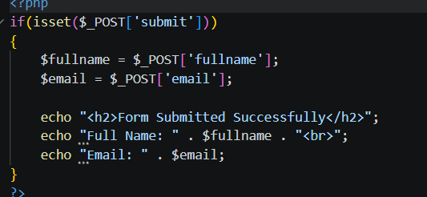
- Dynamic welcome page
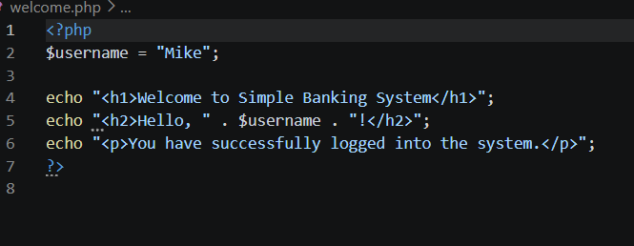
- Form submission system

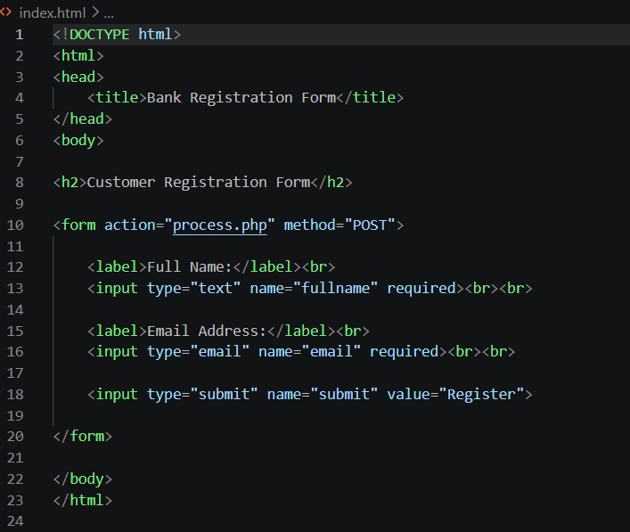

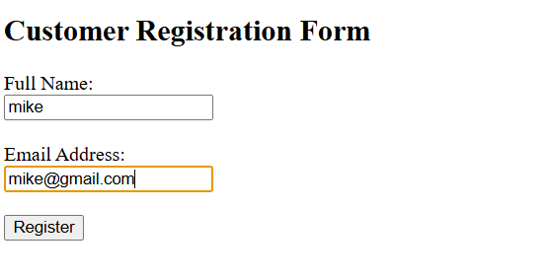
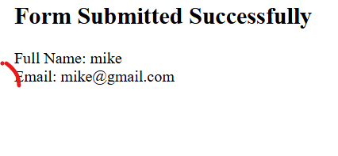

Task 2 – HTML Forms and PHP Integration
- Registration form
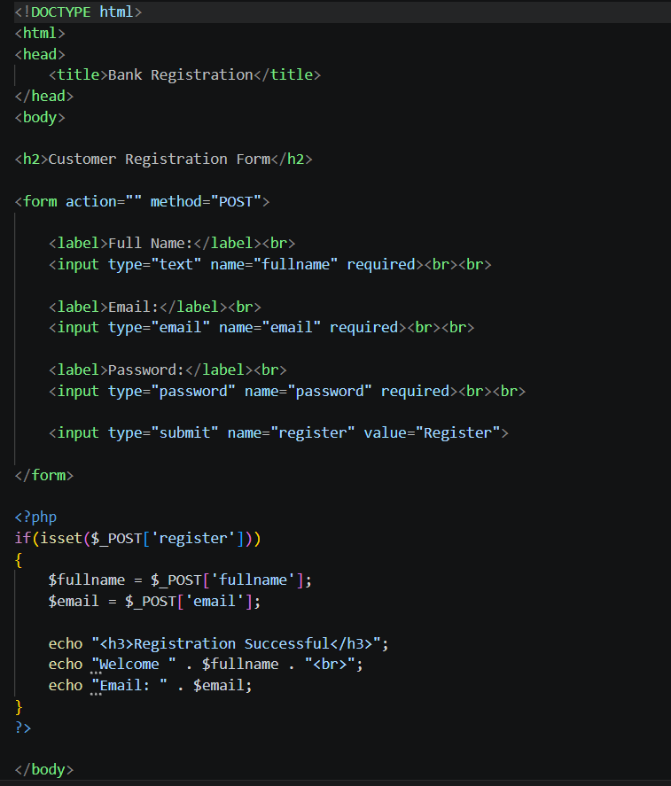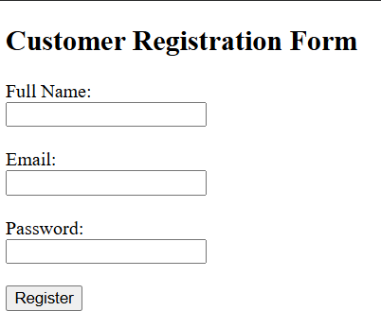
- Login form
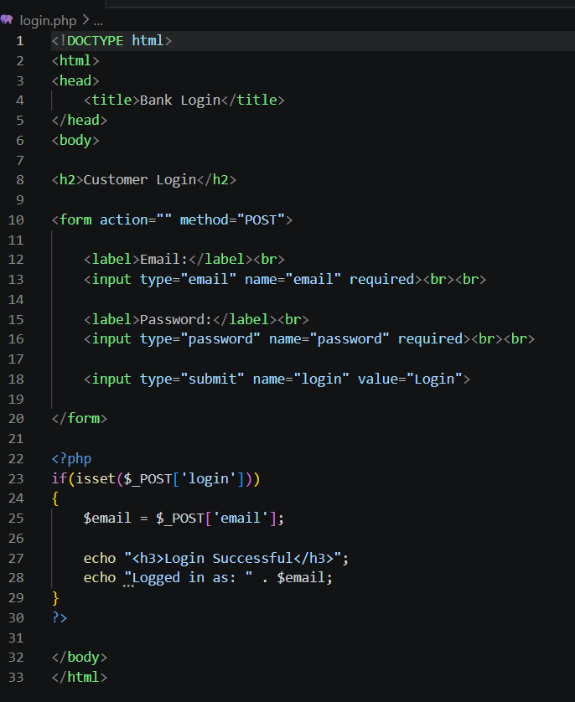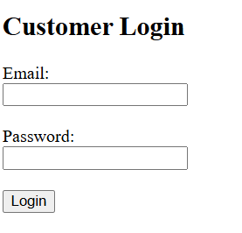
- Contact form
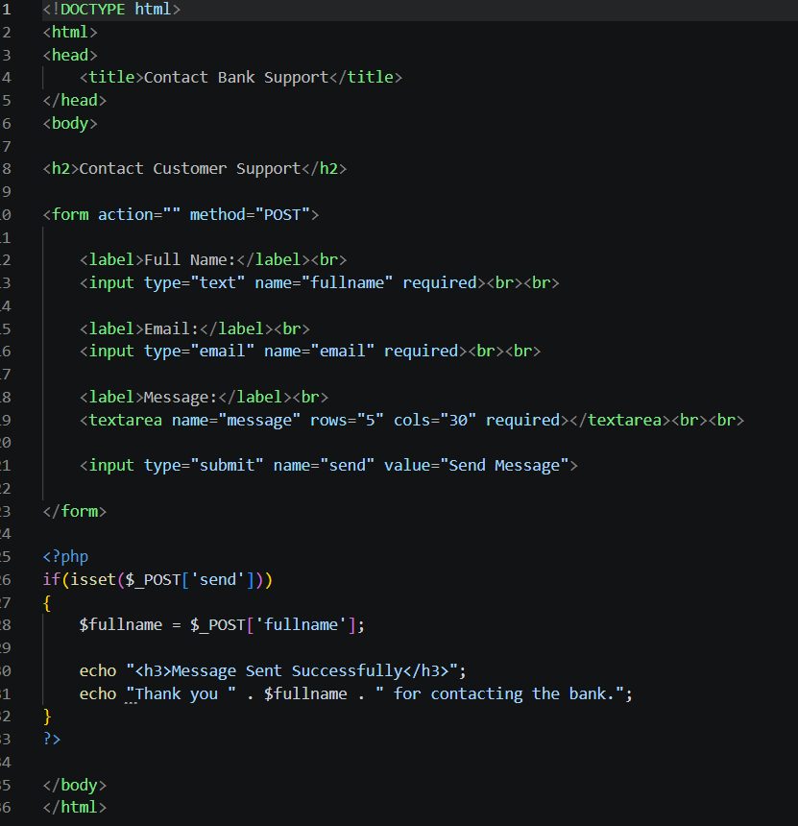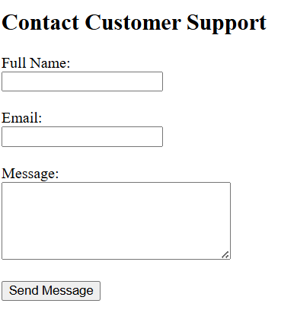

Task 3 – Simple Authentication System
- Basic login page
- 
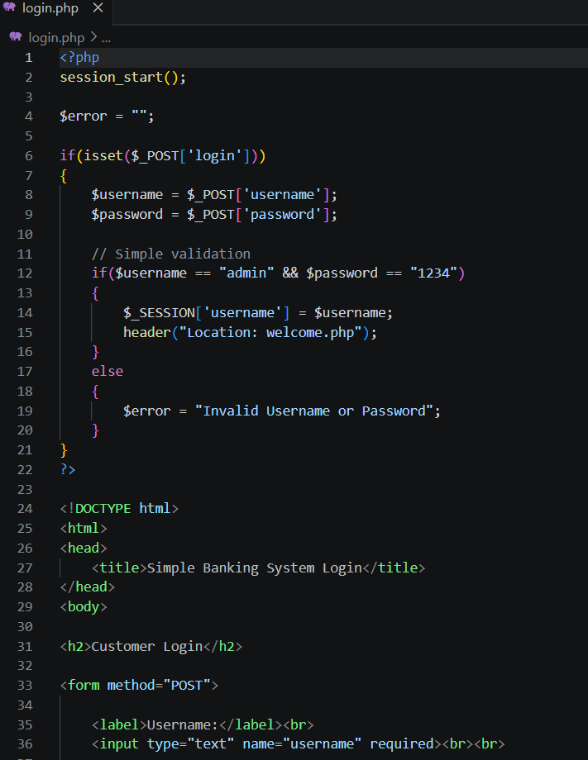

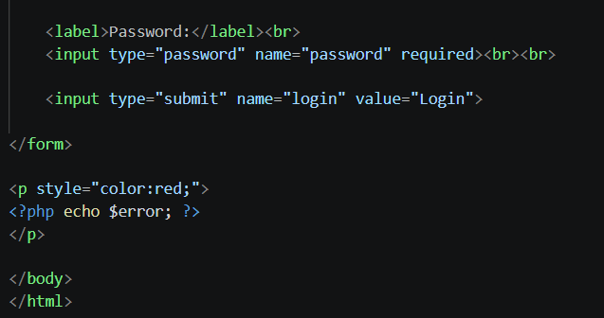
- Username/password valid
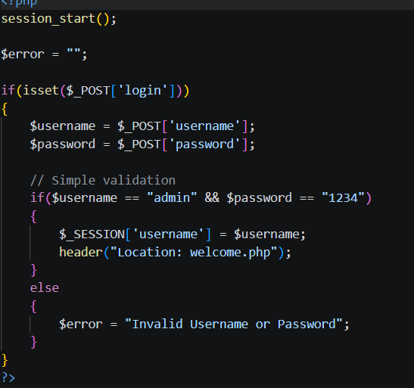

- Session-based welcome page
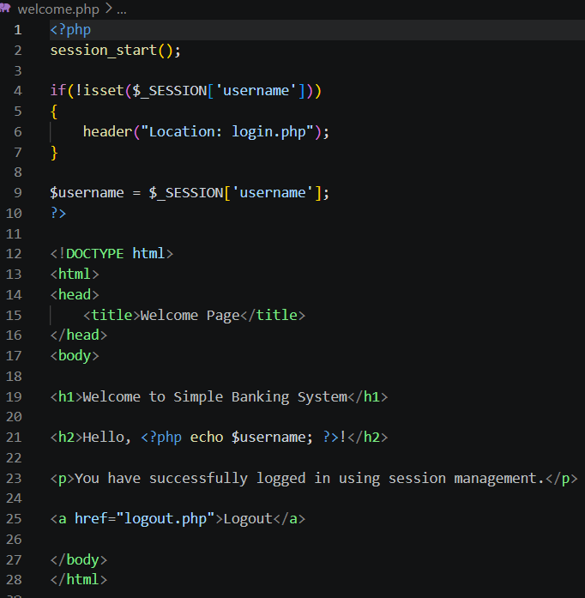

Task 4 – Backend Folder Organization

Folder structure
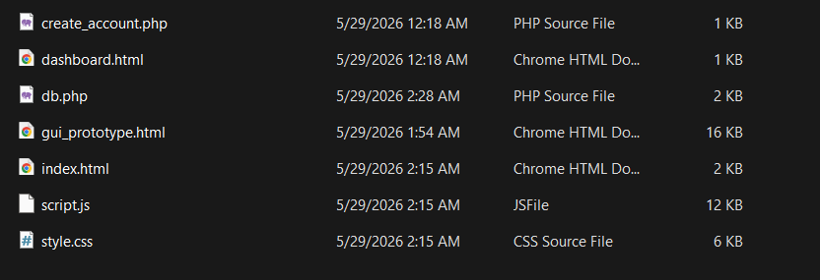

Database connection
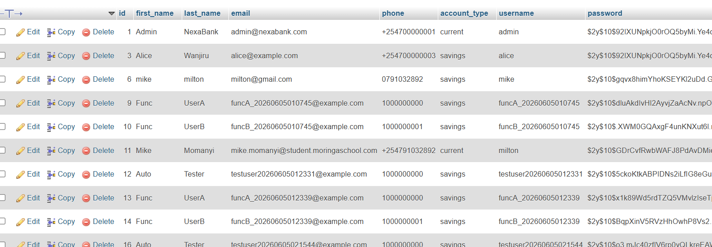

Github repo:
https://github.com/Hami-bit/NexaBank.git

Week 5

Database Components and CRUD Operations
Database screenshot
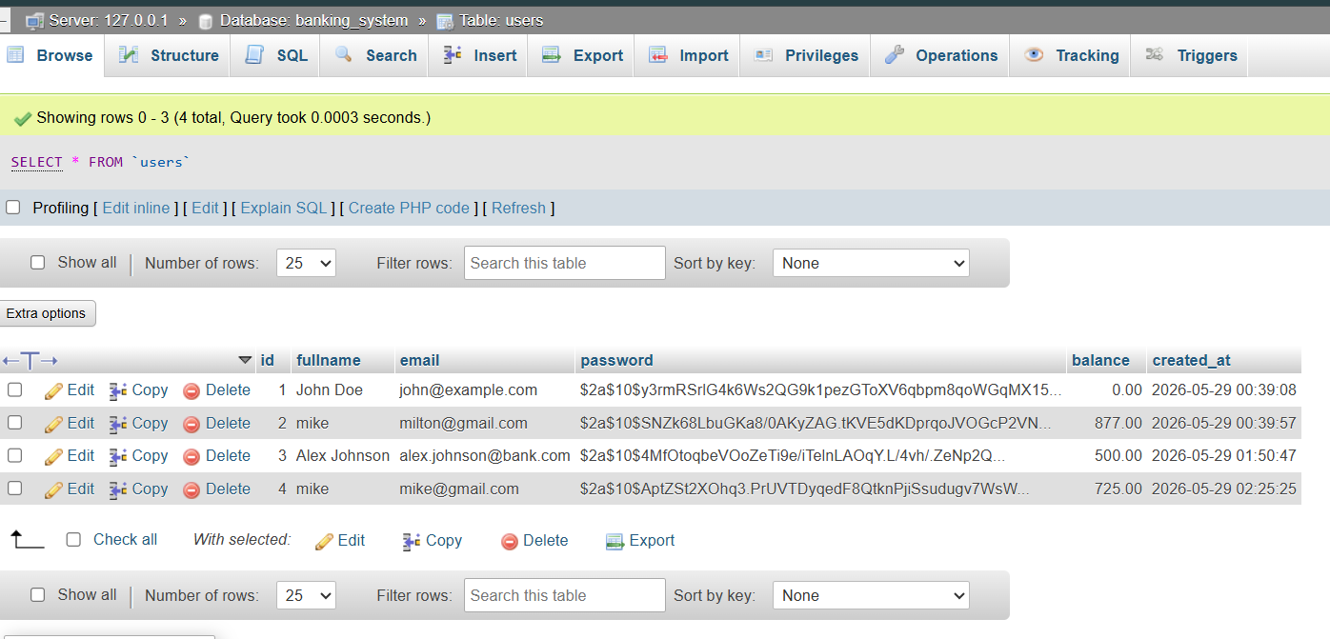

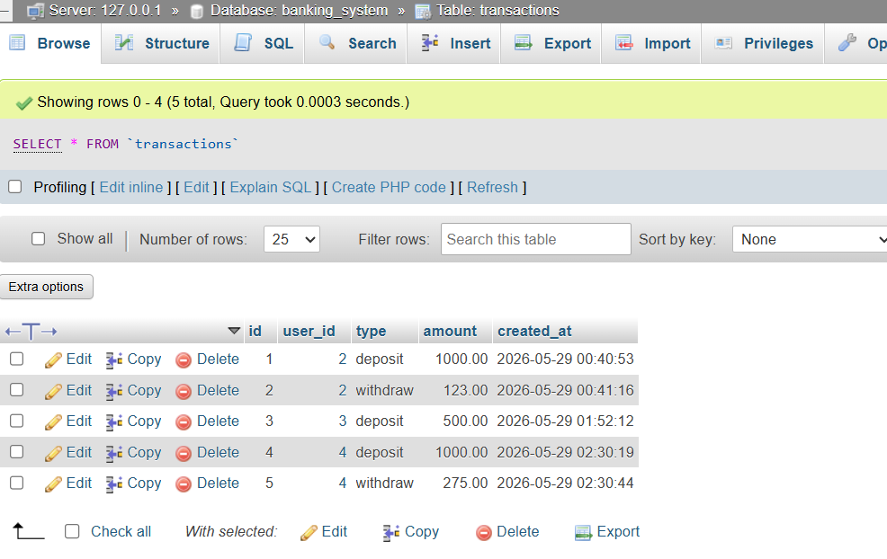
Table creation screenshots
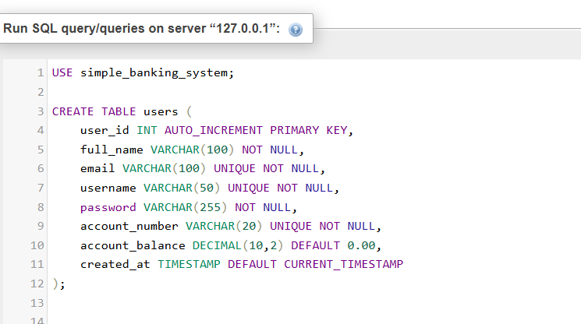

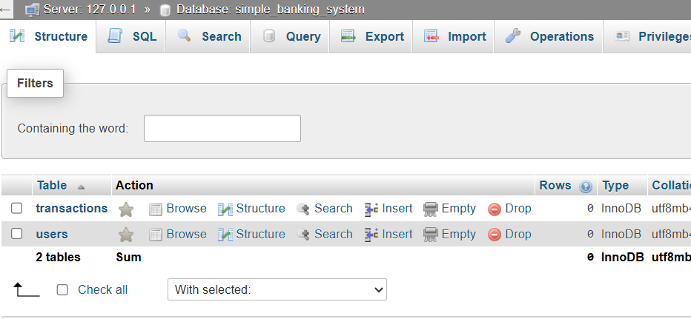

CRUD operation screenshots
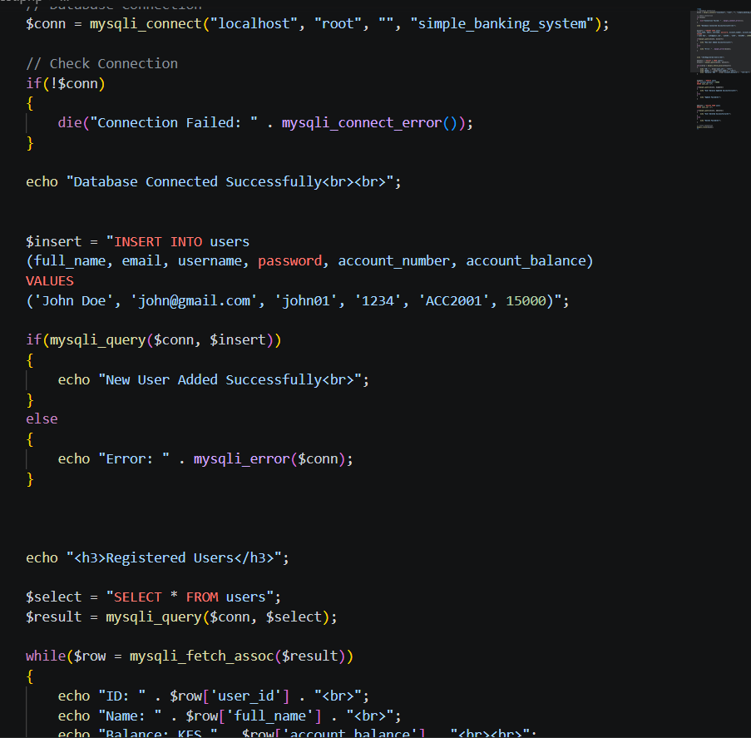
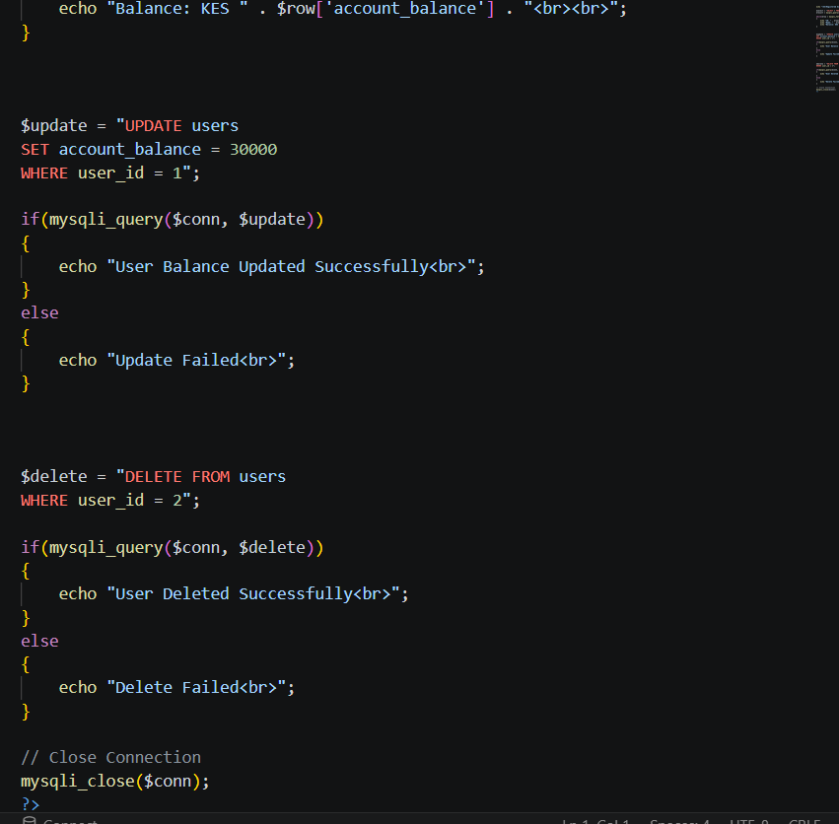

Login database integration screenshots

SQL query screenshots


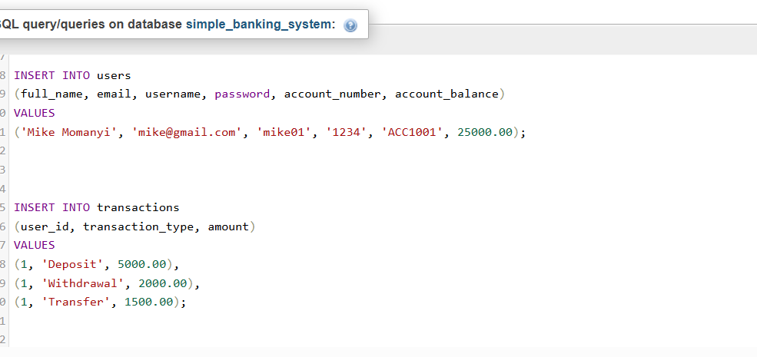
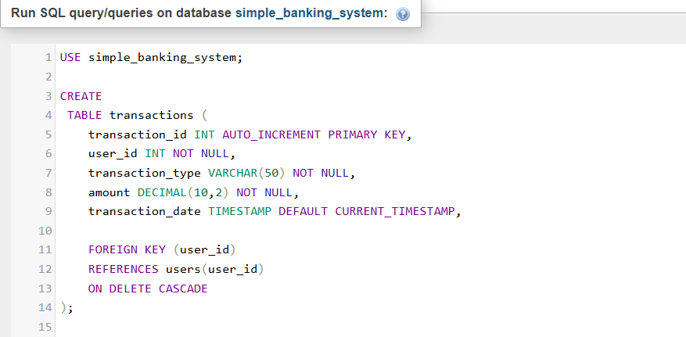

GitHub updates
https://github.com/Hami-bit/NexaBank/tree/main

